CS 1632 - DELIVERABLE 3: Automated System Testing of a Web Application

David Brush

GitHub Username: BaLLiN-BrUsH

URL: <https://github.com/BaLLiN-BrUsH/D2>

I have done Extra Credit #1

**Issues Faced While Writing Code/Tests:**

Creating the code for the application itself was pretty straight forward. I used the “*sinatra_example*” as my reference when developing this deliverable. The most difficult part about this project was understanding how variables were passed from the *table_generator.rb* to the webpages *main.erb* and *display.erb*. Another issue I faced was attempting to implement Extra Credit #2. I found creating a new file based on a user’s input very simple to implement but I wasn’t able to get the truth table text data passed to the newly created text file.

While creating the test cases through Katalon there was a little bit of a learning curve to figure how I wanted to conduct tests and if the tests validated what I wanted to verify amongst the requirements. Overall, I didn’t come across any issues while creating the test cases. The process involved a lot of trial and error.

**Screenshot of executed Katalon Tests:**

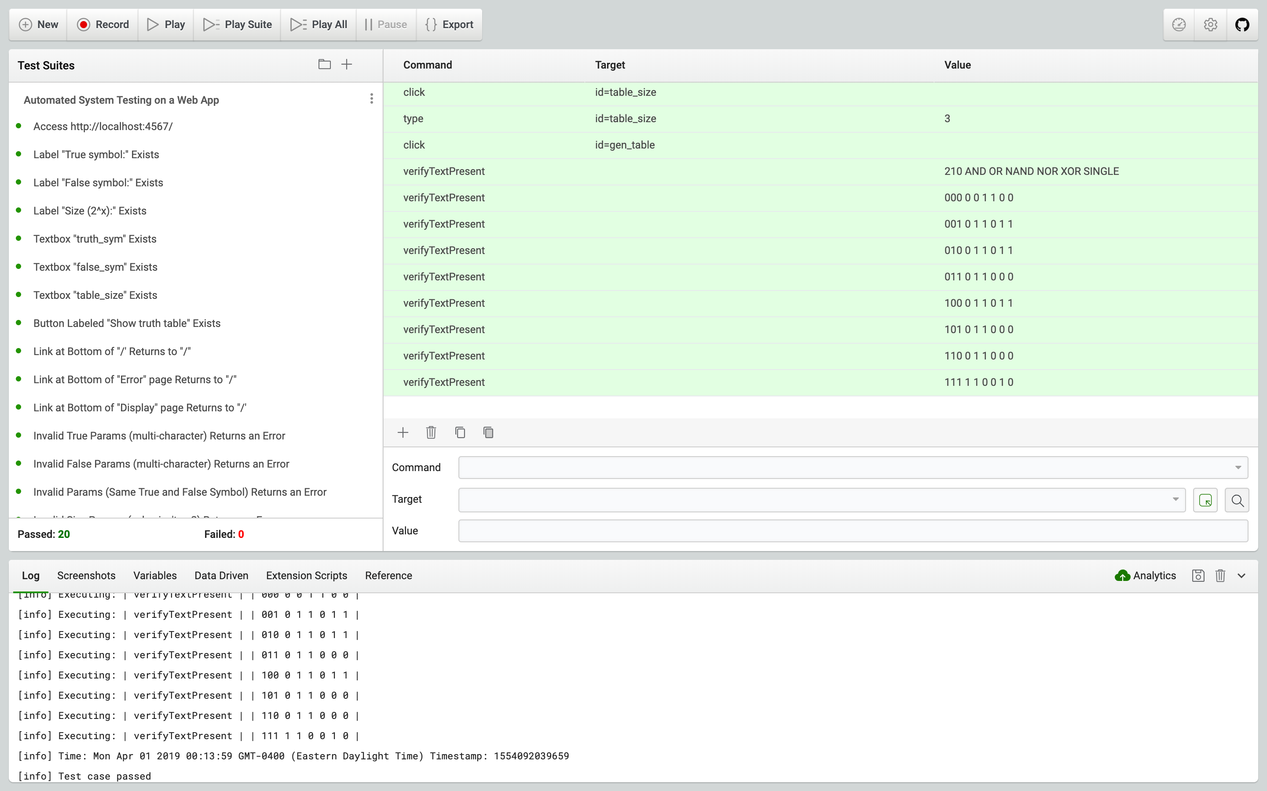

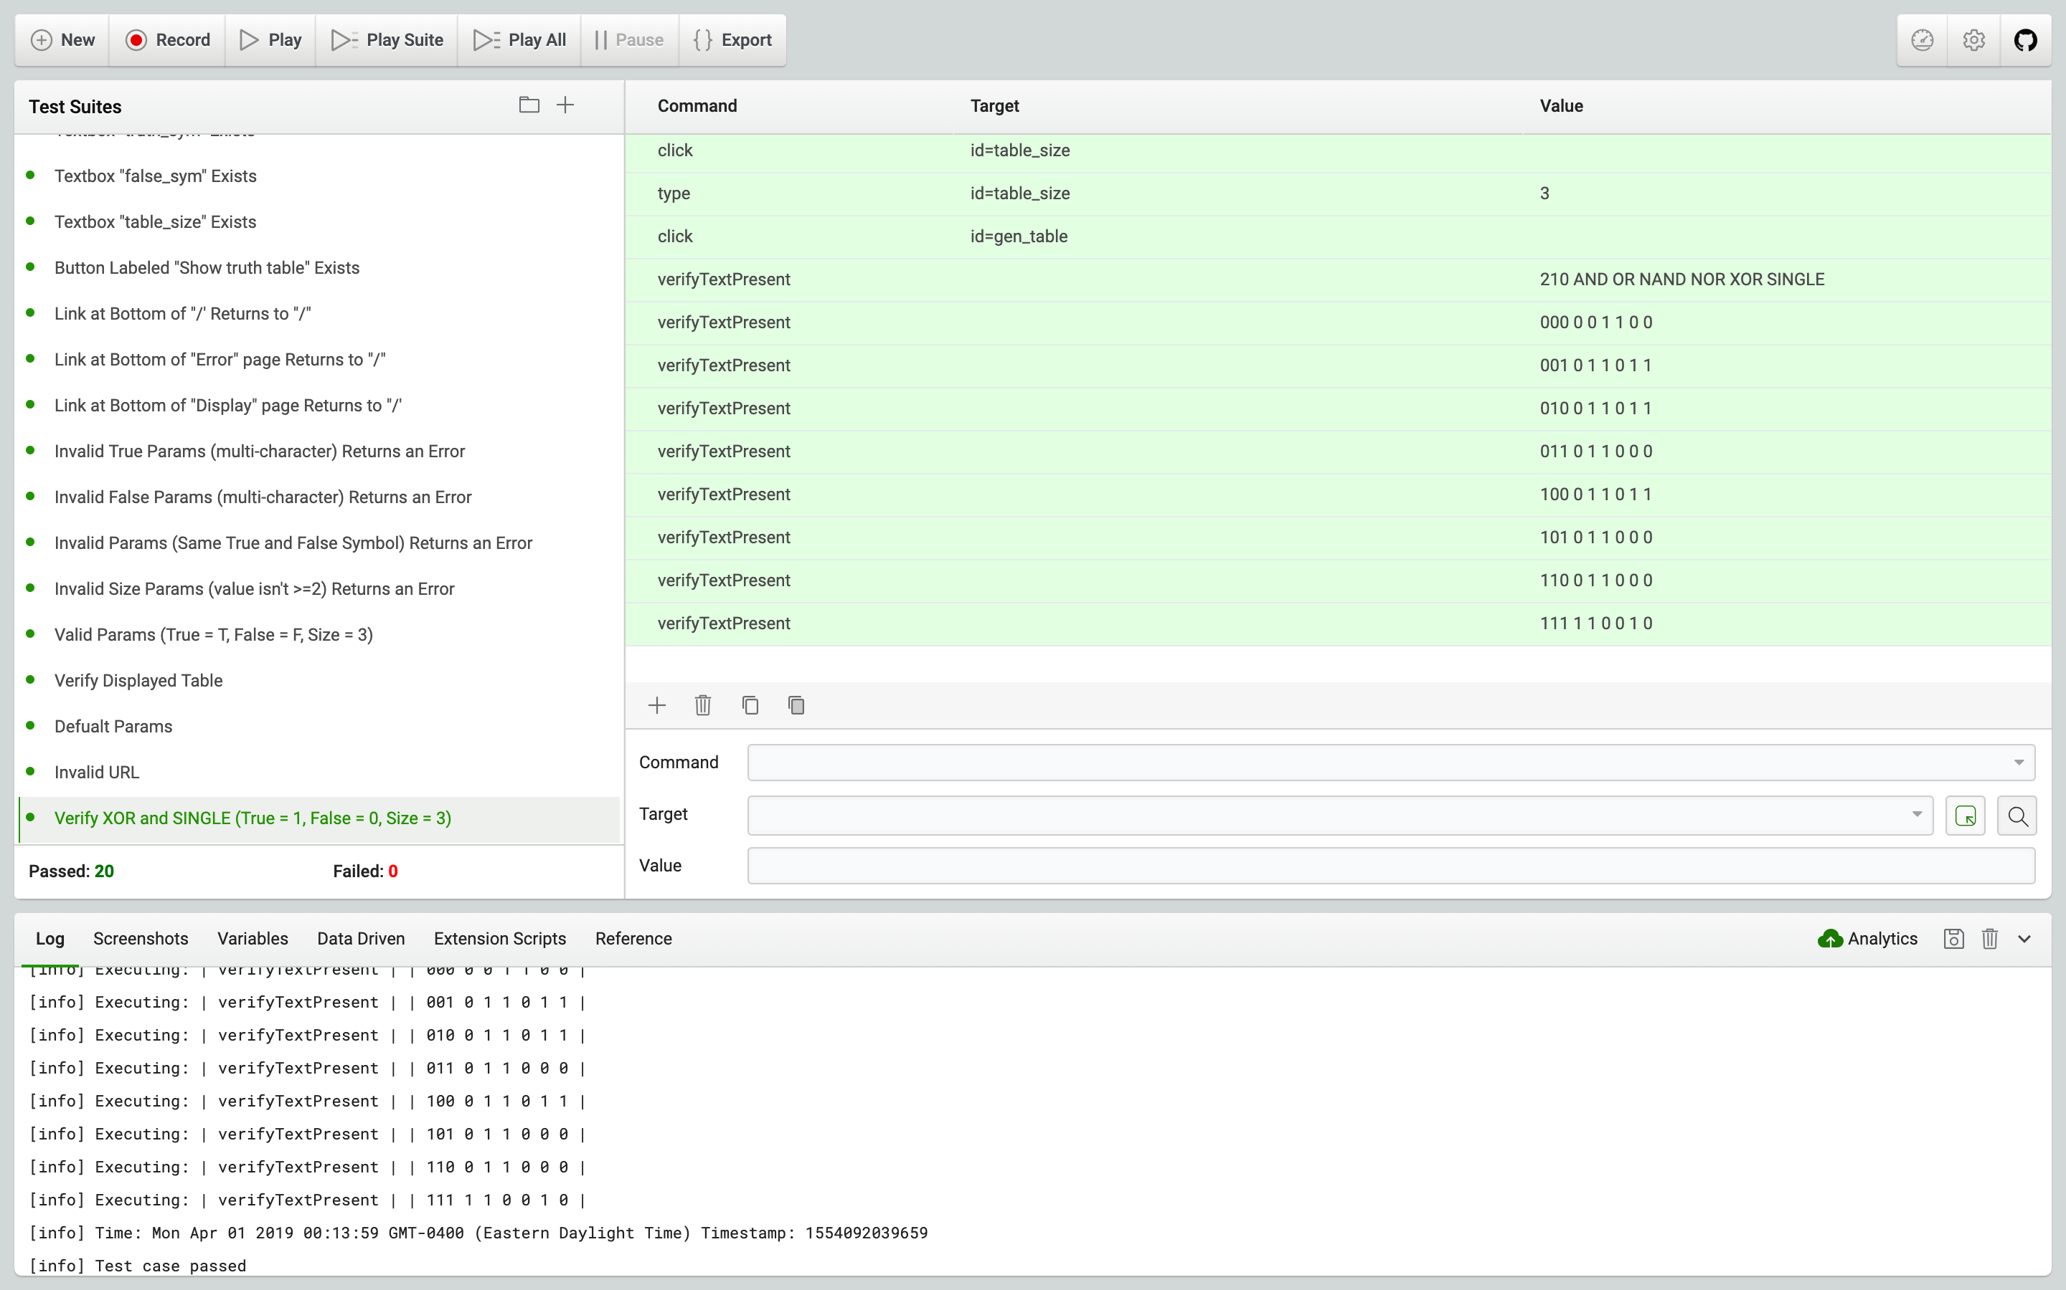

Katalon Tests

1. Access http://localhost:4567/
2. Label “True symbol:” Exists
3. Label “False symbol:” Exists
4. Label “Size (2^x):” Exists
5. Textbox “truth_sym” Exists
6. Textbox “false_sym” Exists
7. Textbox “table_size” Exists
8. Button Labeled “Show truth table” Exists
9. Link at Bottom of “/” Returns to “/”
10. Link at Bottom of “Error” page Returns to “/”
11. Link at Bottom of “Display” page Returns to “/”
12. Invalid True Params (multi-character) Returns an Error
13. Invalid False Params (multi-character) Returns an Error
14. Invalid Params (Same True and False Symbol) Returns an Error
15. Invalid Size Params (value isn’t >=2) Returns an Error
16. Valid Params (True = T, False = F, Size = 3)
17. Verify Displayed Table
18. Default Params
19. Invalid URL
20. Verify XOR and SINGLE (True = 1, False = 0, Size = 3)

Requirements for Web Application

**WEB-APP-MAIN** => Upon accessing the main page ("/", i.e., http://localhost:4567), the system shall display a page with three textboxes and a single submit button, arranged together and each labeled. The first textbox shall be labeled "True symbol:", the second textbox "False symbol:", and the third textbox "Size (2^x):". The button shall be labeled "Show truth table".

**WEB-APP-RETURN-TO-MAIN** => In addition to data already specified, all pages, including the main page itself, shall include a link back to the main page ("/", i.e., http://localhost:4567); however, the text in the link may differ from page to page.

**WEB-APP-PARAMS** => If the "Show truth table" button is pressed and the data is invalid, then an error page containing the text "ERROR" in an H1 tag, and "Invalid parameters." shall be displayed, along with a description explaining the rules for valid data (see below).

Data shall be considered valid if both the true and false symbols are single characters and are distinct from each other (i.e., they shall not be the same character), and that the size is an integer with a value of 2 or greater.

**WEB-APP-SHOW-TABLE** => Upon pressing "Show truth table" with valid parameters, a truth table shall be constructed and displayed using the specified true and false symbols. The top row shall include a descriptor of the value/"bit" (descending, i.e., it should start with the highest number and descend to 0), along with an additional final four column designators labeled "AND", "OR", "NAND", "NOR" in that order.

**WEB-APP-TABLE-COLUMNS** => Additionally, each row in the truth table shall include three additional columns, specifying the result of the AND, OR, NAND, and NOR operators. For multi-element truth operations, we shall consider AND(values) to be true if and only if all elements are true (e.g., "111" is true, but "110" is false); we shall consider OR(values) to be true if and only if any element is true (e.g., "010" is true, but "000" is false); we shall consider NAND to be true if and only if NOT(AND(values)) is true; we shall consider NOR to be true if and only if NOT(OR(values)) is true.

**WEB-APP-DEFUALT-PARAMS** => If no data is entered on the main page in a particular textbox, the default value shall be used. The default value for the true symbol is "T", the default value for the false symbol is "F", and the default value for the size is "3".

**WEB-APP-INVALID-URL** => If a user goes to a URL other than one specified (e.g., "<http://localhost:4567/hotdog>"), the system shall display a page stating "ERROR" (in an h1 tag),as well as the text, "Invalid address.", along with a 404 error code.

**WEB-APP-EXTRA-CREDIT** => Add the following two logical operators - XOR and SINGLE to the truth table. Recall that for any set of values n, XOR is defined as being true if an odd number of values are true.

For example:

XOR(TFT) is false (two trues = even)

XOR(FFT) is true (one true = odd)

The SINGLE operator returns true if and only if a single value is true and all others are false.

For example:

SINGLE(FFFF) is false (zero trues)

SINGLE(FFTF) is true (one true)

Traceability Matrix

**WEB-APP-MAIN:**

* Access http://localhost:4567/
* Label “True symbol:” Exists
* Label “False symbol:” Exists
* Label “Size (2^x):” Exists
* Textbox “truth_sym” Exists
* Textbox “false_sym” Exists
* Textbox “table_size” Exists
* Button Labeled “Show truth table” Exists

**WEB-APP-RETURN-TO-MAIN:**

* Link at Bottom of “/” Returns to “/”
* Link at Bottom of “Error” page Returns to “/”
* Link at Bottom of “Display” page Returns to “/”

**WEB-APP-PARAMS:**

* Invalid True Params (multi-character) Returns an Error
* Invalid False Params (multi-character) Returns an Error
* Invalid Params (Same True and False Symbol) Returns an Error
* Invalid Size Params (value isn’t >=2) Returns an Error
* Valid Params (True = T, False = F, Size = 3)

**WEB-APP-SHOW-TABLE:**

* Verify Displayed Table

**WEB-APP-TABLE-COLUMNS:**

* Verify Displayed Table

**WEB-APP-DEFUALT-PARAMS:**

* Default Params

**WEB-APP-INVALID-URL:**

* Invalid URL

**WEB-APP-EXTRA-CREDIT:**

* Verify XOR and SINGLE (True = 1, False = 0, Size = 3)